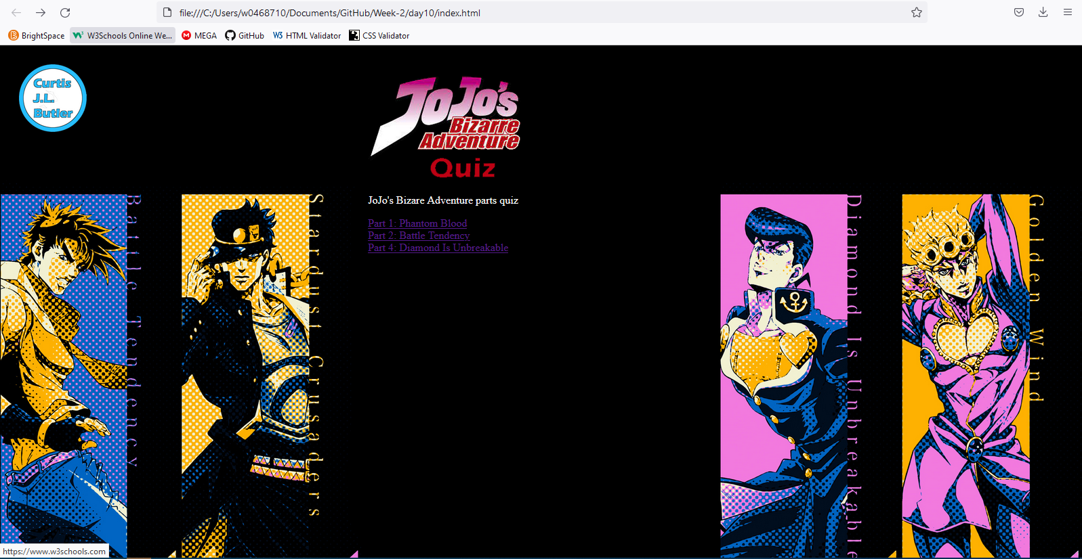

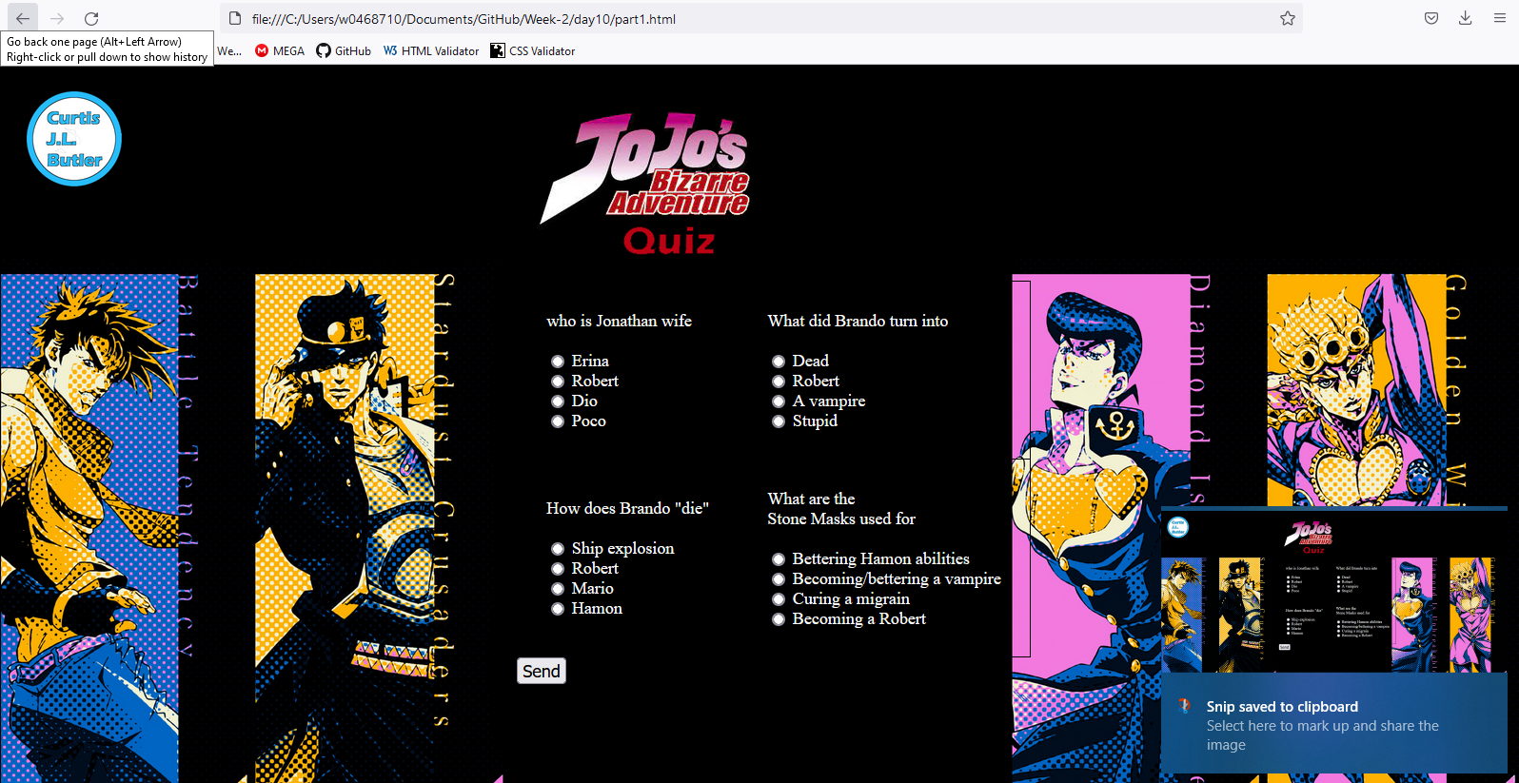

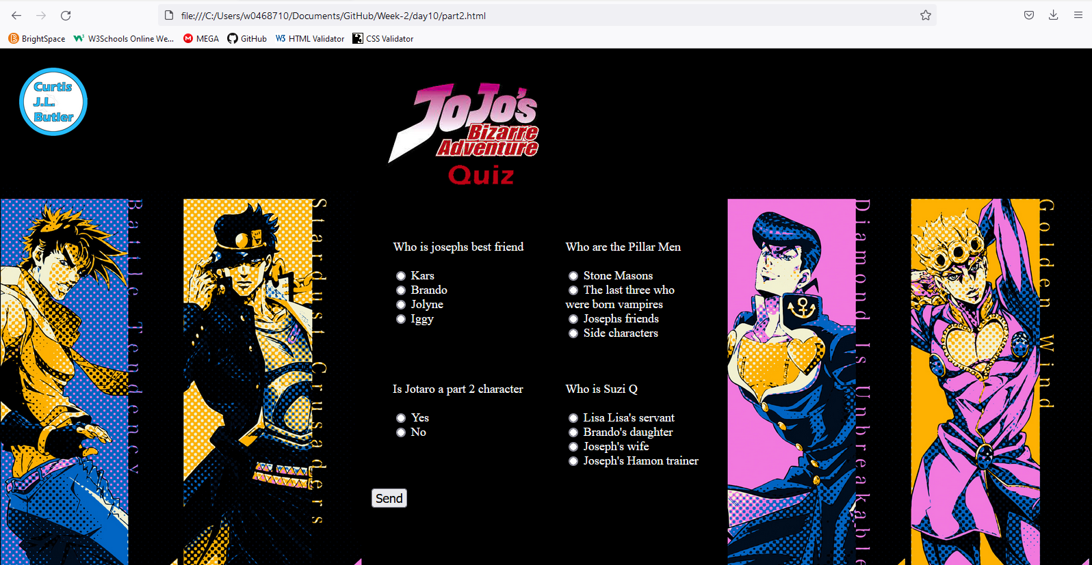

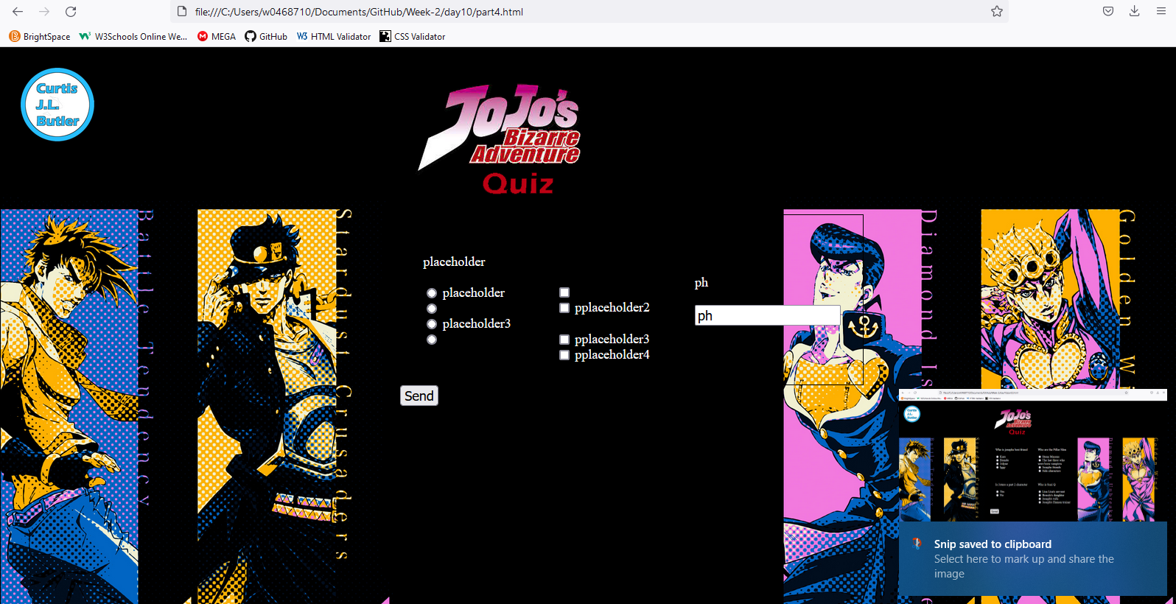

Style sheet

@media only screen and (*orientation*: landscape) {}

nav {

*float*: left;

*padding*: 20px;

*width*: 30%;

}

article {

*float*: left;

*padding*: 20px;

*width*: 50%;

}

aside {

*float*: left;

*padding*: 20px;

*width*: 30%;

}

    table {

*overflow-x*: auto;

    }

a {

*text-align*: left;

}

    label {

*color*: white;

    }

    body {

*background-size*: cover;

*background-image*: url("background.jpg");

*background-repeat*: no-repeat;

    }

    @media only screen and (*max-width*: 1067px) {

        /* for mobile phones: */

    }

    table, th, td {

*border*: 1px solid black;

*border-collapse*: collapse;

*text-align*: left;

*padding*: 30px;

    }

    h1 {

*font-size*: 200%;

*text-align*: center;

*border*: 1px solid black;

    }

form, label, input {

*font-size*: 100%;

*text-align*: left;

}

    .item1 {

*grid-column*: 2/4;

    }

    .item2 {

*grid-row*: 2/4;

*grid-column*: 3;

    }

        p {

*color*: white;

    }

@media only screen and (*max-width*: 1067px) {

    /* for mobile phones: */

    @media only screen and (*orientation*: landscape) {

        table {

*overflow-x*: auto;

        }

        .grid-container1 {

*display*: grid;

*grid-template-columns*: 10% 10% 10%;

*padding*: 10px;

        }

        .grid-container1 > div {

*font-size*: 18px

        }

        table, th, td {

*border*: 1px solid black;

*border-collapse*: collapse;

*text-align*: left;

        }

        .item1 {

*grid-column*: 2/4;

        }

        .item2 {

*grid-row*: 2/4;

*grid-column*: 3;

        }

        }

    }

    form {

*font-size*: 18px;

    }

Index

<!DOCTYPE html>

<html lang="en-ca">

<head>

<title>Responsive</title>

    <link rel="stylesheet" href="stylesheet.css">

    <meta name="viewport" content="width=device-width, initial-scale=1.0">

</head>

<body>

<nav>

     <img src="../websitelogoo.png" alt="my logo" width=100>

    </nav>

     <article>

        <p style="text-align: left;"><img src="index.png" width="300" alt="jojos quiz logo"></p>

        <p style="color: white; text-align: left;">JoJo's Bizare Adventure parts quiz<br></p>

        <a href="part1.html">Part 1: Phantom Blood</a><br>

        <a href="part2.html">Part 2: Battle Tendency</a><br>D

        <a href="part4.html">Part 4: Diamond Is Unbreakable</a><br>

    </article>

<aside></aside>

</body>

</html>

Quiz part 1

<!DOCTYPE html>

<html lang="en-ca">

<head>

<title>Responsive</title>

    <link rel="stylesheet" href="stylesheet.css">

    <meta name="viewport" content="width=device-width, initial-scale=1.0">

</head>

<body>

<nav>

<img src="../websitelogoo.png" alt="my logo" width=100>

</nav>

<article>

<img src="index.png" width="300" alt="jojos quiz logo" style="padding:20px"><br>

                <form>

                <table>

                    <tr>

                    <td>

                    <label for="wijw">who is Jonathan wife</label><br><br>

                    <input type="radio" id="erina" name="wijw" value="erina">

                    <label for="erina">Erina</label><br>

                    <input type="radio" id="robert" name="wijw" value="robert">

                    <label for="robert">Robert</label><br>

                    <input type="radio" id="Dio" name="wijw" value="Dio">

                    <label for="Dio">Dio</label><br>

                    <input type="radio" id="poco" name="wijw" value="poco">

                    <label for="poco">Poco</label><br>

                </td>

                <td>

                    <label for="wdbti">What did Brando turn into</label><br><br>

                    <input type="radio" id="dead" name="wdbti" value="dead">

                    <label for="dead">Dead</label><br>

                    <input type="radio" id="robert" name="wdbti" value="robert">

                    <label for="robert">Robert</label><br>

                    <input type="radio" id="vampire" name="wdbti" value="vampire">

                    <label for="vampire">A vampire</label><br>

                    <input type="radio" id="stupid" name="wdbti" value="stupid">

                    <label for="stupid">Stupid</label><br>

                </td>

            </tr>

            <tr>

                <td>

                <label for="hdbd">How does Brando "die"</label><br><br>

                <input type="radio" id="ship explosion" name="wdbd" value="ship explosion">

                <label for="ship explosion">Ship explosion</label><br>

                <input type="radio" id="robert" name="hdbd" value="robert">

                <label for="robert">Robert</label><br>

                <input type="radio" id="mario" name="hdbd" value="mario">

                <label for="mario">Mario</label><br>

                <input type="radio" id="hamon" name="hdbd" value="hamon">

                <label for="hamon">Hamon</label><br>

            </td>

            <td>

                <label for="watsmuf">What are the<br> Stone Masks used for</label><br><br>

                <input type="radio" id="Bettering_Hamon_abilities" name="watsmuf" value="Bettering_Hamon_abilities">

                <label for="Bettering_Hamon_abilities">Bettering Hamon abilities</label><br>

                <input type="radio" id="vampire" name="watsmuf" value="vampire">

                <label for="vampire">Becoming/bettering a vampire</label><br>

                <input type="radio" id="migrain" name="watsmuf" value="migrain">

                <label for="migrain">Curing a migrain</label><br>

                <input type="radio" id="robert" name="watsmuf" value="robert">

                <label for="robert">Becoming a Robert</label><br>

            </td>

        </tr>

                </table>

                <input type="submit" value="Send">

                </form>

            </article>

            <aside></aside>

</body>

</html>

Part 2

<!DOCTYPE html>

<html lang="en-ca">

<head>

<title>Responsive</title>

    <link rel="stylesheet" href="stylesheet.css">

    <meta name="viewport" content="width=device-width, initial-scale=1.0">

</head>

<body>

<nav>

<img src="../websitelogoo.png" alt="my logo" width=100>

</nav>

<article>

<img src="index.png" width="300" alt="jojos quiz logo" style="padding:20px"><br>

                <form>

                <table>

                    <tr>

                    <td>

                    <label for="wijbf">Who is josephs best friend</label><br><br>

                    <input type="radio" id="kars" name="wijbf" value="kars">

                    <label for="kars">Kars</label><br>

                    <input type="radio" id="brando" name="wijbf" value="brando">

                    <label for="brando">Brando</label><br>

                    <input type="radio" id="jolyne" name="wijbf" value="jolyne">

                    <label for="jolyne">Jolyne</label><br>

                    <input type="radio" id="Iggy" name="wijbf" value="iggy">

                    <label for="iggy">Iggy</label><br>

                </td>

                <td>

                   <br> <label for="watpm">Who are the Pillar Men</label><br><br>

                    <input type="radio" id="stonemasons" name="watpm" value="stonemasons">

                    <label for="stonemasons">Stone Masons</label><br>

                    <input type="radio" id="tltwwbv" name="watpm" value="tltwwbv">

                    <label for="tltwwbv">The last three who<br>   were born vampires</label><br>

                    <input type="radio" id="jojofriend" name="watpm" value="jojofriend">

                    <label for="jojofriend">Josephs friends</label><br>

                    <input type="radio" id="sidechar" name="watpm" value="sidechar">

                    <label for="sidechar">Side characters</label><br>

                </td>

            </tr>

            <tr>

                <td>

                <label for="ijap2c">Is Jotaro a part 2 character</label><br><br>

                <input type="radio" id="yes" name="ijap2c" value="yes">

                <label for="yes">Yes</label><br>

                <input type="radio" id="no" name="ijap2c" value="no">

                <label for="no">No</label><br><br><br>

            <td>

                <label for="wisq">Who is Suzi Q</label><br><br>

                <input type="radio" id="lls" name="wisq" value="lls">

                <label for="lls">Lisa Lisa's servant</label><br>

                <input type="radio" id="brando" name="wisq" value="brando">

                <label for="brando">Brando's daughter</label><br>

                <input type="radio" id="jojow" name="wisq" value="jojow">

                <label for="jojow">Joseph's wife</label><br>

                <input type="radio" id="jojot" name="wisq" value="jojot">

                <label for="jojot">Joseph's Hamon trainer</label><br>

            </td>

        </tr>

                </table>

                <input type="submit" value="Send">

                </form>

            </article>

            <aside></aside>

</body>

</html>

Part 3

<!DOCTYPE html>

<html lang="en-ca">

<head>

<title>Responsive</title>

    <link rel="stylesheet" href="stylesheet.css">

    <meta name="viewport" content="width=device-width, initial-scale=1.0">

</head>

<body>

<nav>

<img src="../websitelogoo.png" alt="my logo" width=100>

</nav>

<article>

<img src="index.png" width="300" alt="jojos quiz logo" style="padding:20px"><br>

                <form>

                <table>

                    <tr>

                    <td>

                    <label for="placeholder">placeholder</label><br><br>

                    <input type="radio" id="placeholder" name="placeholder" value="placeholder">

                    <label for="placeholder">placeholder</label><br>

                    <input type="radio" id="placeholder2" name="placeholder" value="placeholder2">

                    <label for="placeholder2"></label><br>

                    <input type="radio" id="placeholder3" name="placeholder" value="placeholder3">

                    <label for="placeholder3">placeholder3</label><br>

                    <input type="radio" id="placeholder4" name="placeholder" value="placeholder4">

                    <label for="placeholder4"></label><br>

                </td>

                <td>

                   <br> <label for="pplaceholder"></label><br><br>

                    <input type="checkbox" id="pplaceholder" name="pplaceholder" value="pplaceholder">

                    <label for="pplaceholder"></label><br>

                    <input type="checkbox" id="placeholder2" name="pplaceholder" value="pplaceholder2">

                    <label for="pplaceholder2">pplaceholder2<br></label><br>

                    <input type="checkbox" id="pplaceholder3" name="pplaceholder" value="pplaceholder3">

                    <label for="pplaceholder3">pplaceholder3</label><br>

                    <input type="checkbox" id="pplaceholder4" name="pplaceholder" value="pplaceholder4">

                    <label for="pplaceholder4">pplaceholder4</label><br>

            <td>

                <label for="ph">ph</label><br><br>

                <input type="text" id="ph" name="ph" value="ph">

            </td>

        </tr>

                </table>

                <input type="submit" value="Send">

                </form>

            </article>

            <aside></aside>

</body>

</html>